Increase in stranded sea lions along Oregon coast due to leptospirosis
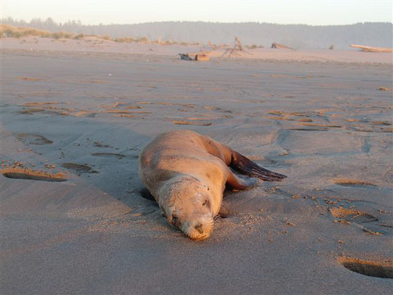

An increase in stranded sea lions has been observed along the Oregon and California Coast over the past couple of months. “We are now getting calls for multiple sick or dead sea lions daily, which is higher than normal,” said Rice, an OSU Marine Mammal Institute researcher who works at the university’s Hatfield Marine Science Center in Newport. At least 8 cases have been confirmed through the Oregon Veterinary Diagnostic Laboratory at Oregon State University since the outbreak began in late September, primarily from beaches in Lincoln, Tillamook and Clatsop counties, with numerous other reports of sick and dead sea lions that have not undergone testing. Leptospirosis is a disease caused by bacteria that can affect people, dogs, cattle, marine mammals, rodents and other wildlife. It occurs worldwide but we only sporadically see outbreaks in marine mammals. Spread usually occurs through contact with urine or other bodily fluids and can lead to kidney failure, fever, weakness, muscle pain and other systemic signs. In Oregon, young male sea lions are typically affected and usually show signs of dehydration, depression and reluctance to use their hind flippers.
The last outbreak affecting California sea lions in Oregon was observed in 2010. The current increase in strandings and the potential for leptospirosis to affect dogs and people who have direct contact raise concerns from a public health standpoint. Although there is a low risk of transmission to humans, the main risk is to pets that approach and are in contact with body fluids from sick or dead sea lions.
People who observe sick sea lions or other marine mammals on the beach are advised to keep a wide berth (at least 50 ft). Pets should not be allowed to have contact with sick or dead animals as it is a disease that can be transmitted to pets and cause severe disease. “There are vaccines available to protect dogs and horses against leptospirosis, please contact your veterinarian for information and vaccine availability” said Emilio DeBess, state public health veterinarian of the Oregon Health Authority. Dogs should always be kept on a leash and not allowed to interact with stranded marine mammals. Dogs that become ill after being exposed to sick or dead sea lions should be taken to their veterinarian right away.
Persons seeing dead or sick marine mammals on Oregon beaches are encouraged to call the Oregon State Police 1-800-452-7888.
It is a violation of federal and state laws to harass, disturb, touch, or feed marine mammals.
Questions regarding wildlife diseases can be directed to the ODFW wildlife health hotline at: 1-866-968-2600.
This information was compiled by Oregon Department of Fish and Wildlife, the Oregon Marine Mammal Stranding Network, and Oregon Health Authority.
Additional information can be found at: http://www.dfw.state.or.us/wildlife/health_program/docs/Leptospirosis_and_marine_mammals.pdf
Or on the CDC website: http://www.cdc.gov/nczved/divisions/dfbmd/diseases/leptospirosis/

