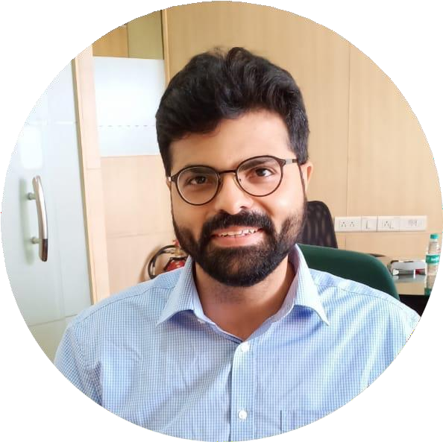

# Contact

MOBILE/WHATSAPP:

+91 9594 311 333

EMAIL:

[jammykc@hotmail.com](mailto:jammykc@hotmail.com)

# Hobbies

Non-Fiction Reading- Biographies, Self- Improvement Strategies, Value Investing, Human Intellect and History.

Western Classical Music- Dream to attend a Live Concert of The Berlin Philharmonic Orchestra.

Getting closer to becoming a fitness buff.

Playing Live Chess on the phone.

Discovering hidden Food joints in Mumbai.

Learning to Sail currently. Hope to learn to fly an Airplane when I can afford the lessons!

Being a Life-Long Learner.

JAMSHYD COOPER

Veterinarian

## EDUCATION

**High School:** Cathedral & John Connon School, completed in 2003**.**

**BVSc.**: Veterinary Graduation from Bombay Veterinary College in 2013.

**NAVLE:** The International Council for Veterinary Assessment’s North American Veterinary License Examination passed in 2023.

## WORK EXPERIENCE

### Top Dog Pets Clinic, Mumbai- Clinical Externship followed by being entrusted with overnight care of critical patients at their home.

2014 – 2016

Received my foundation in Clinical Principles and Ethics of Practice from Dr. Makarand Chausalkar and Surgical Principles from Dr. Barry Kalsy.

Owing to the lack of 24x7 facilities, I cared for critical patients at their

owner’s home overnight.

### Crown Vet, Mumbai - Founding In- Charge of Emergency Service

2016 - 2018

Opted to exclusively work nights and established the first night emergency service for canine and feline patients in Mumbai.

### Freelance Visiting Vet

2018 - 2023

Supported several private small animal practitioners in Mumbai for their patients requiring soft tissue surgery, anesthesia, and critical care.

### Founding Core Team Veterinarian for the Tata Trusts’ Advanced

**Veterinary Care Foundation, Small Animal Hospital Mumbai.**

November 2023 – Current

This is a visionary institution just opened on 2nd. January, 2024. It is a world-class vet hospital conceived by Mr. Ratan N. Tata, to be a catalyst of excellence, in small animal veterinary care in India. The aim and values of this organization are aligned with mine and I continue to remain grateful for being a core clinical team member from its planning stage. Upon completion of Residency training and a Board Certification from the USA, I aim to return to India and contribute towards uplifting the standards of veterinary care across the country, with this institution developing to be the national epicenter of advancements in veterinary medicine, graduate teaching and clinical research in India.