Policy for outside course credit requests

- Credit for elective courses not offered at Carlson College of Veterinary Medicine must meet the following criteria:
  - Student must present a paragraph summarizing how the course is important to their professional development to the curriculum committee.
  - Students requesting credit for courses offered outside Oregon State University Carlson College of Veterinary Medicine must provide to the curriculum committee:
    - A course syllabus written by the course director that contains the following:
      - Evidence that the course is designed and facilitated by a veterinarian or faculty member at a teaching facility.
      - A description of the course contents including a listing of laboratory and lecture hours
      - Course objectives.
      - Course learning outcomes.
      - Method for monitoring outcomes.
      - Course credits.
- Credit will be assigned according to university guidelines-
  - Approximately 1 credit will be assigned for each:
    - 10 hours lecture
    - 20 hours discussion
    - 30 hours laboratory
  - When transferring in course work from a semester system institution, each semester credit will approximately equal 1.5 quarter credits.
- The decision whether to assign credit is at the discretion of the curriculum committee.

This policy was proposed by the Courses and Curriculum Committee and approved by the Faculty on June 18, 2019.

Approved: 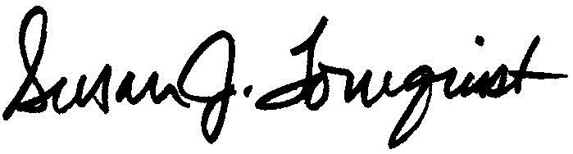 Date: June 18, 2019
Dr. Susan J. Tornquist
Lois Bates Acheson Dean

